E-Portfolio Reflective Piece
Security and Risk Management
Student: Nankyer Dawuk | Role: Digital Lead

1. What – Description of the Project and My Role
The SRM_PCOM7E module required the completion of a team-based Security and Risk Management project centred on a fictional small-to-medium enterprise, Pampered Pets, which was undergoing a proposed digital transformation. As the Digital Lead within a four-member team, my primary responsibility was to conceptualise, research, and articulate the digitalization strategy that formed the foundation of the team's risk assessment. This included proposing the implementation of an e-commerce portal, a cloud-based Enterprise Resource Planning (ERP) system, a Customer Relationship Management (CRM) solution, integration with international suppliers, and a digital marketing framework.
The team's Unit 6 deliverable the Risk Identification Report drew upon two principal frameworks: the STRIDE threat modelling methodology applied to the company's current IT infrastructure (Tarandach and Coles, 2021), and the NIST SP 800-30 framework used to assess risks arising from the proposed digitalization (Putra and Soewito, 2023). My role intersected both areas: I was responsible for defining the digital transformation roadmap whose risks were then assessed by the Risk Lead, and for ensuring that the proposed mitigations in the digitalization section were technically grounded and practically actionable. The report was submitted on 9 March 2026 and represented the team's collective synthesis of cybersecurity theory, risk methodology, and business strategy.

2. So What – Analysis and Interpretation

2.1 The Security and Risk Management Process
Engaging with the SRM process through this project substantially deepened my understanding of risk as a multi-dimensional concept. Prior to this module, my professional background in arbitration, and government administration gave me a procedural understanding of risk primarily in legal, compliance, and regulatory contexts. The application of NIST SP 800-30 and STRIDE, however, introduced me to the technical and operational dimensions of risk in ways I had not previously encountered. I came to appreciate that cybersecurity risk is not merely a technical concern but an organisational one, embedded in business processes, human behaviour, and strategic decision-making (Jouini, Rabai and Aissa, 2014).
As Digital Lead, proposing the digitalization of Pampered Pets required me to think concurrently about business value and security exposure a challenging but rewarding intellectual exercise. For instance, recommending the integration of international suppliers for cost reduction introduced not only supply chain risks but also GDPR compliance obligations (ICO, 2021). This interplay between operational opportunity and security risk is a core tension in modern organisational management, and navigating it analytically was a significant learning outcome for me.

2.2 My Individual Contributions
My principal contribution was the development of the proposed digitalization section of the report, including the six-month digitalisation roadmap and the associated risk assessment under NIST SP 800-30. I identified and articulated the key risk vectors introduced by each proposed digital initiative for example, the e-commerce portal's exposure to data breach, unauthorised access, and payment fraud, as well as the cloud ERP/CRM systems' vulnerability to misconfiguration, service outage, and cloud security failures. I also proposed corresponding mitigations, including PCI-DSS compliant payment gateways, TLS encryption, multi-factor authentication, CDN-based DDoS protection, and GDPR-compliant data governance.
Reflecting on this contribution honestly, I recognise that while my legal background gave me a strong instinct for compliance and regulatory risk particularly around GDPR and data protection my technical grounding in cloud infrastructure was initially limited. I had to invest additional effort in understanding cloud security concepts such as shared responsibility models, misconfiguration risks, and the security implications of distributed architectures. This gap, once identified, motivated me to approach the cloud security components of the digitalization proposal more rigorously, drawing on current academic and practitioner literature to ensure credibility (Aslan et al., 2023).

2.3 My Experience as a Member of a Development Team
Working in a geographically dispersed, asynchronous team presented both operational and interpersonal challenges that solo academic work does not replicate. Coordinating contributions across roles with Osvaldo Macanga leading threat modelling, Merapelo Maikano managing the risk assessment, and Hana Aljeilani overseeing editing and review required clear communication, mutual accountability, and iterative feedback. I found that my professional background in inter-institutional collaboration, developed through government and intergovernmental roles, provided a useful foundation for navigating team dynamics.
However, I also encountered the challenge common to all collaborative academic projects: reconciling different working styles, pacing expectations, and levels of prior technical knowledge. There were moments where alignment between the digitalization proposals I developed and the risk assessment frameworks applied by the Risk Lead required negotiation and revision. This experience reinforced the importance of early-stage alignment on scope and methodology a lesson directly applicable to professional project environments. As Shukla et al. (2022) note, effective security assurance in organisations depends as much on team coordination and process clarity as on technical competence.

2.4 Impact on Professional and Personal Development
On a personal level, the project challenged my instinct to approach problems through a purely legal or procedural lens. The requirement to engage with technical frameworks like STRIDE and to propose architecturally informed security mitigations stretched my analytical comfort zone productively. I came to appreciate that intellectual discomfort, when managed constructively, is itself a signal of genuine learning an insight that aligns with Rolfe, Freshwater and Jasper's (2001) reflective framework, which situates dissonance and challenge as catalysts for professional growth. Attached below are evidence of the conversation between myself and team members.

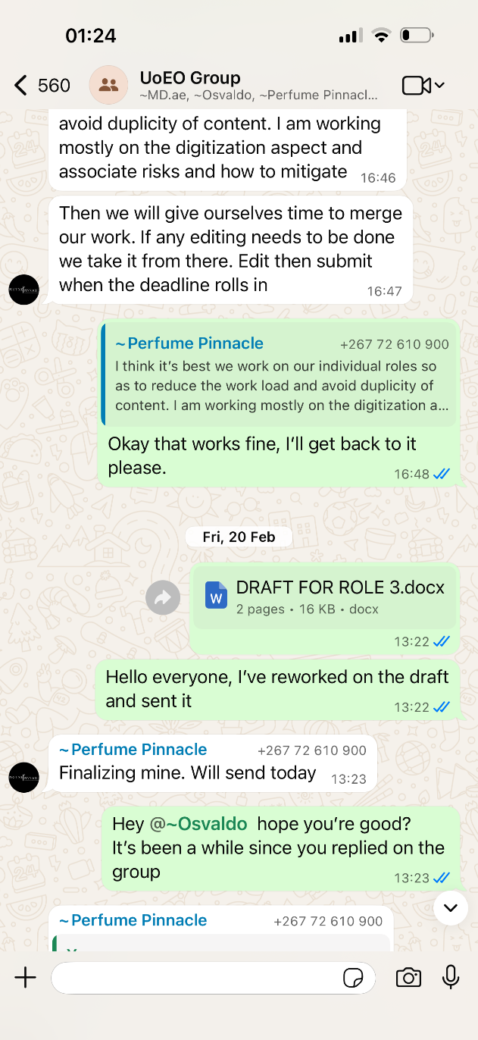
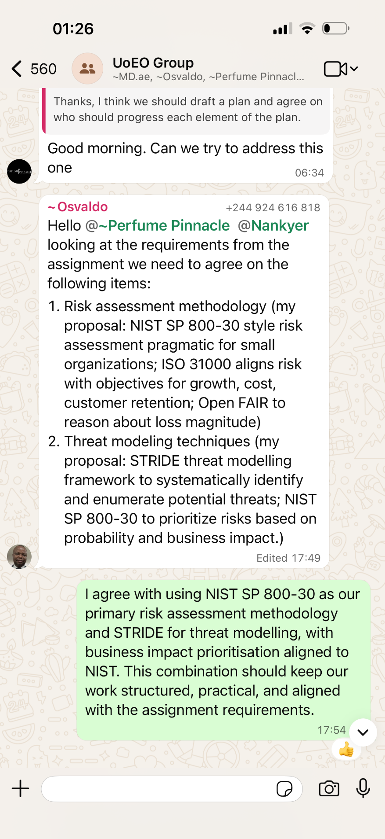
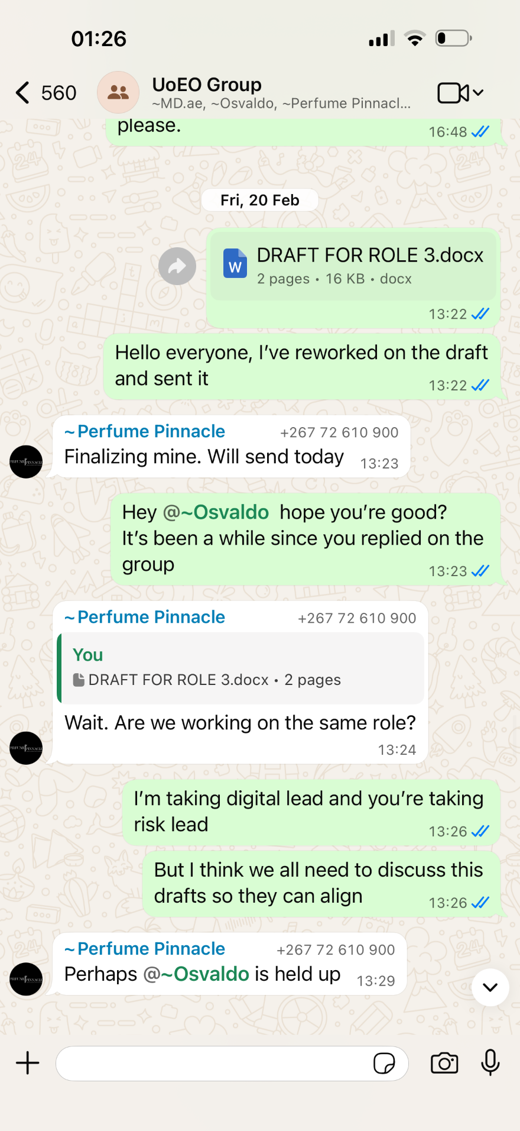
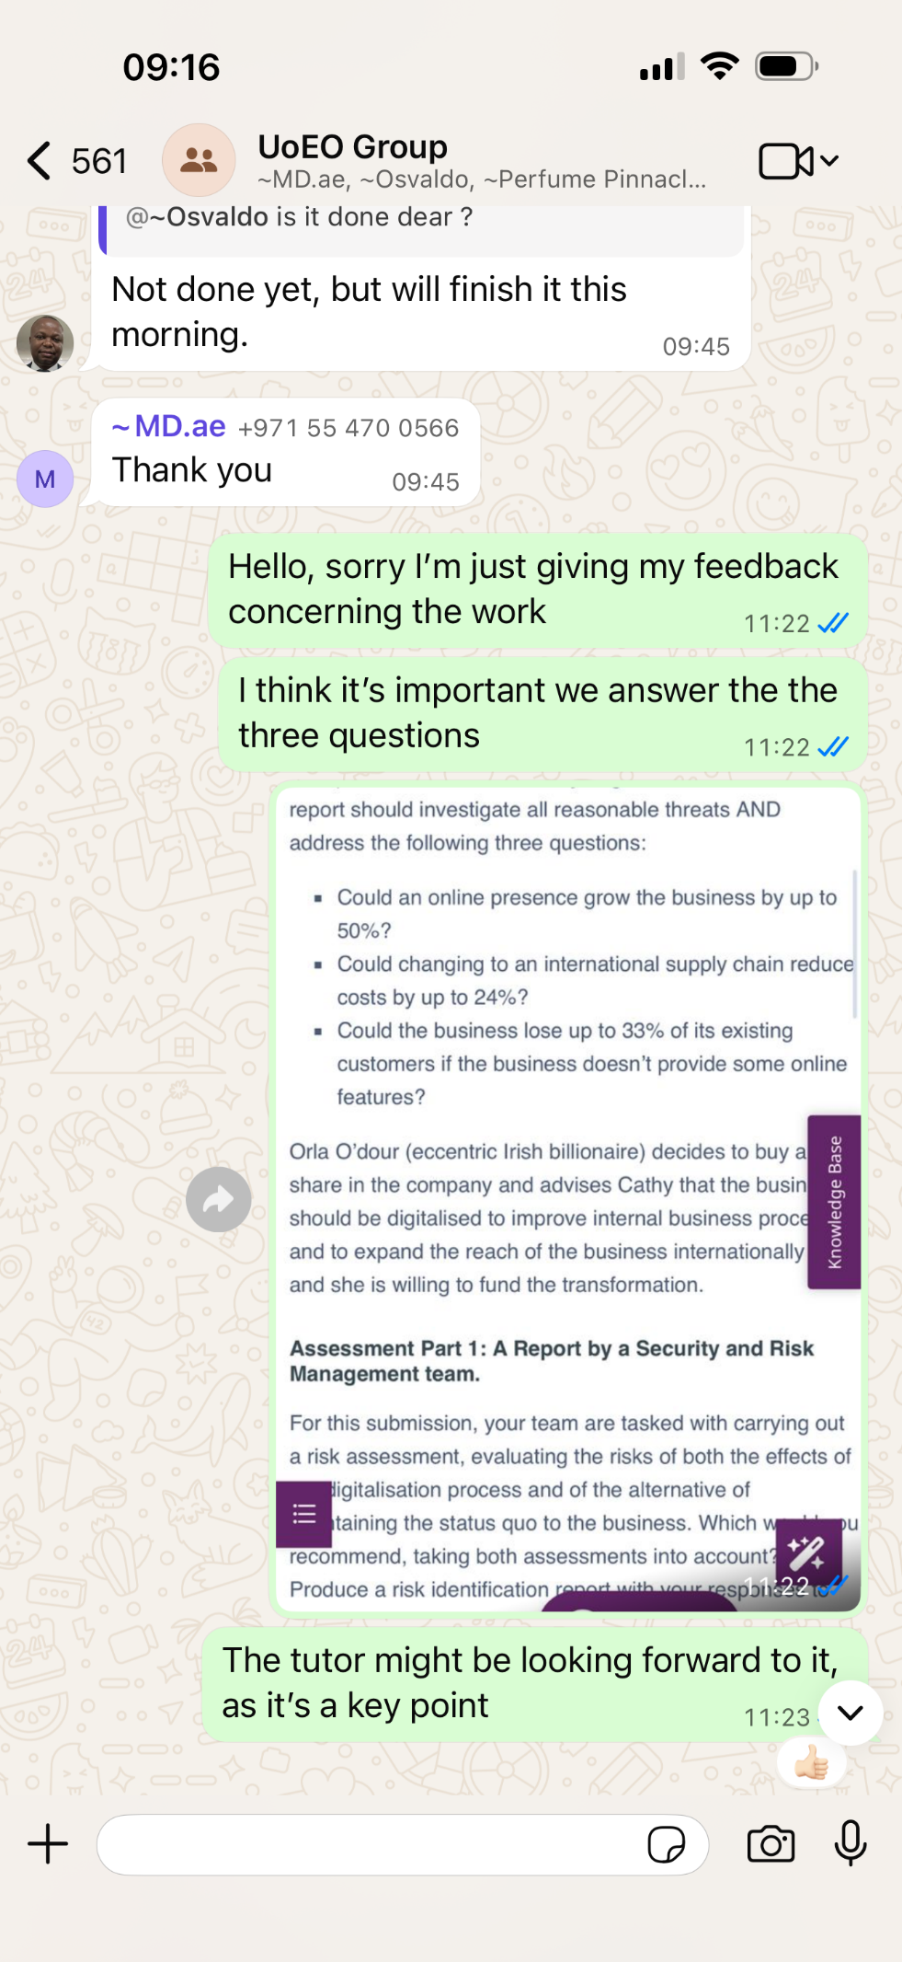

3. Now What – Future Actions and Application
Going forward, I intend to consolidate and extend the learning from this module in several concrete ways. First, I will pursue deeper technical development in cloud security, with a view to understanding AWS and Azure security architectures at an applied level. This will directly address the knowledge gap I identified during the cloud ERP/CRM risk assessment component of the project. Specifically, I plan to undertake the AWS Certified Cloud Practitioner certification as a structured pathway to this knowledge.
Finally, the collaborative experience of this module has reinforced the value of structured team processes in risk management work. In future group projects and professional settings, I will advocate for early-stage scope alignment and shared methodology documentation practices that would have made several moments of our team's revision process less time-intensive. The module has made me a more reflective, analytically versatile, and professionally self-aware practitioner, and I carry those outcomes forward into the remaining modules of my MSc.

References
Aslan, Ö., Aktuğ, S.S., Ozkan, M., Yılmaz, A.A. and Akin, E. (2023) 'A comprehensive review of cyber security vulnerabilities, threats, attacks and solutions', Electronics, 12(6). Available at: https://www.mdpi.com/2079-9292/12/6/1333 (Accessed: 6 March 2026).
Information Commissioner's Office (ICO) (2021) Guide to the UK General Data Protection Regulation (UK GDPR). London: ICO. Available at: https://ico.org.uk/for-organisations/guide-to-data-protection (Accessed: 28 February 2025).
Jouini, M., Rabai, L.B.A. and Aissa, A.B. (2014) 'Classification of security threats in information systems', Procedia Computer Science, 32, pp. 489–496.
Putra, A.P. and Soewito, B. (2023) 'Integrated methodology for information security risk management using ISO 27005:2018 and NIST SP 800-30 for insurance sector', International Journal of Advanced Computer Science and Applications, 14(4), pp. 625–633.
Rolfe, G., Freshwater, D. and Jasper, M. (2001) Critical Reflection in Nursing and the Helping Professions: A User's Guide. Basingstoke: Palgrave Macmillan.
Shukla, A., Katt, B., Nweke, L.O., Yeng, P.K. and Weldehawaryat, G.K. (2022) 'System security assurance: A systematic literature review', Computer Science Review, 45.
Tarandach, I. and Coles, M.J. (2021) Threat Modeling: A Practical Guide for Developing Teams. California: O'Reilly Media.

